A slide from the USCIS stakeholder call.
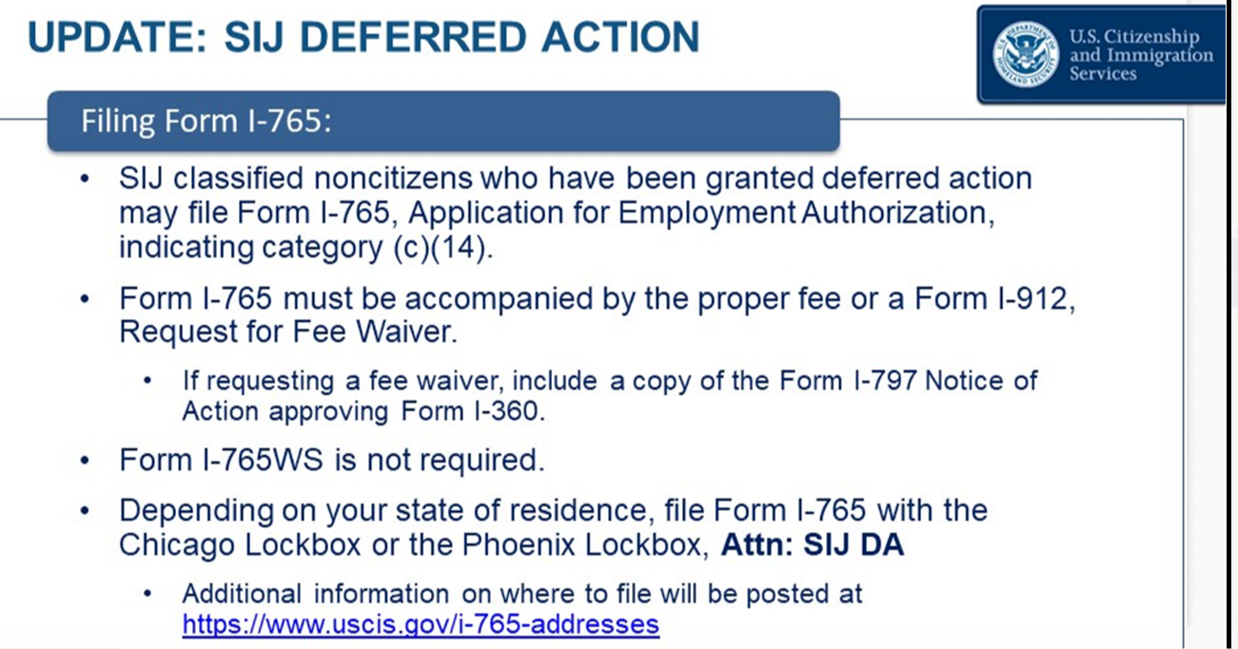

I recommend filing a fee waiver since no proof of income should be required for the I-912 Fee waiver
